Names and NSIDs: Yinsheng Dong (yid164); Ruida Xie (rux793); Hao Li (hal356);

Project: jEdit

Change Number: [6]

Date: 04/05/2018

**Show/Hide whitespace**

1. **Change Request：**

Currently jEdit shows a red dot at the end of every line. Newline is the only whitespace symbol that jEdit shows. Add menu item Show/Hide whitespace under menu View to allow the user to choose whether all whitespace symbols (newlines, blanks, and tabs) will be shown. At this stage you do not have to worry about editing of the text with whitespace showing.

1. **Concept Location:**

Firstly, I analyzed jedit_gui.prop in the org.gjt.sp.jedit package It is known that every menu option is stored in this file, so I kept track to around 470 line in this file, and I found “View menu”. Every view menu item is in this location. Secondly, I checked how the menu function works. I found every menu item is executed by actions.xml in the package JEdit.org.gjt.sp.jedit, so I know it is needed to add action code in this file. The next thing I did is to find TextArea class in the org.gjt.sp.jedit.textarea package, because add/hide whitespace is executed in the TextArea.

|  |  |  |  |  |
| --- | --- | --- | --- | --- |
| **#** | **File name** | **Tool used** | **Located?** | **Comments** |
| 1 | jedit_gui.prop | Eclipse Searching (files) “interface definition” | Changed | Every menu item and interface component are in this file, so I kept track to around 470 line in this file, and I found “View menu” So I think the show/hide white space should add in the menu. |
| 2 | actions.xml | Eclipse Searching (files) “actions.xml” | Changed | I looked over this file, and I found this file can handle TextArea method, and execute function here, because we need to add a new item in the view, and do hide/show whitespace method, so some code will be added in this file |
| 3 | TextArea.java | Simply read | Changed | I looked over this TextArea panel class. After 270 lines, I found there are many text area method is written in this file, so if I want to add new java function, this is the place that I can write in. |
| 4 | JEditBuffer.java | Get from parameters of TextArea.java | Propagating | The global variable in TextArea class to control buffer in text area. This file represents the contents of an opened text file |
| 5 | TextAreaPainter.java | Get from parameter from TextArea.java | Propagating | The global variable in TextArea class to control painting in text area. This file is the component responsible for displaying the text of current buffer |

**Table 1. The list of all the classes visited during concept location.**

1. **Impact Analysis:**

**Table 2. The list of all the classes visited during impact analysis.**

|  |  |  |  |  |
| --- | --- | --- | --- | --- |
| **#** | **Class name** | **Tool used** | **Impacted?** | **Comments** |
| 1 | jedit_gui.prop | Eclipse Searching (files) “interface definition” | Yes | UI parts are in this class. It needs to add “show/hide whitespace” menu item under the View menu |
| 2 | actions.xml | Eclipse Searching (files) “actions.xml” | Yes | Functions are executed in this file, it will be needed to add actions code. |
| 3 | TextArea.java | Simply read | Yes | This class is use to show the text area and do some implementations. |
| 4 | JEditBuffer.java | Get from parameter of TextArea.java | No | It will not be impacted because it is using by TextArea as parameter |
| 5 | TextAreaPainter.java | Get from parameter of TextArea.java | No | It will not be impacted because it is using by TextArea as parameter |

1. **Learning process:**

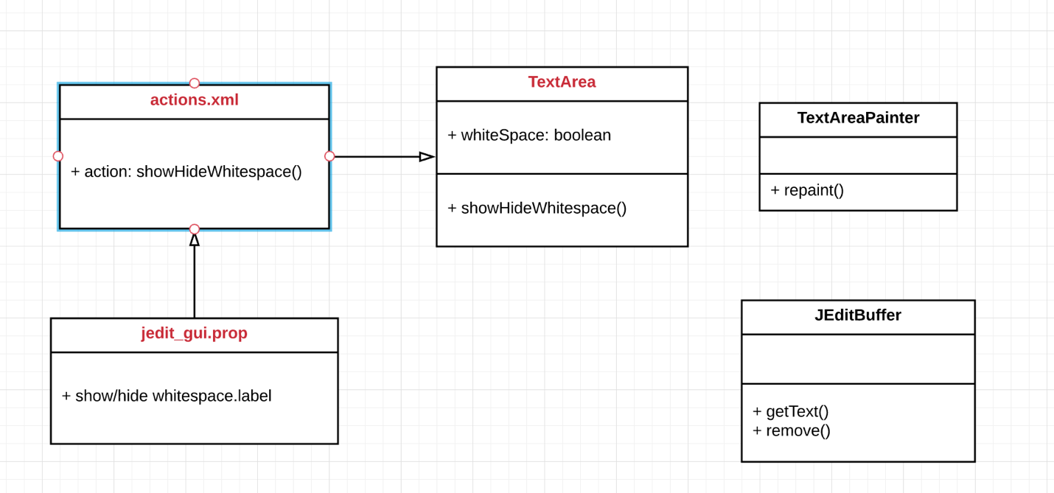

Figure 1 class diagram

1. **Description of the implementation:**

I implemented actions.xml, jedit_gui.prop, and TextArea.java.

I added menus item (show/hide whitespace) in the jedit_gui.prop under view part, so UI will be display the menu item “show/hide whitespace”

I created method showHideWhitespace() in TextArea class, and added a global Boolean variable to control if show or hide, so the function will change the whitespace, the tab, and the newline to “\S”, “\T” and “\N”.

I added action method to actions.xml by calling showHideWhitespace() method, so it can be running to in this function.

1. **Sources:**
   1. <https://www.online-convert.com/file-format/prop>
   2. <http://onecrayon.com/tea/docs/action-xml/>
   3. <https://docs.oracle.com/middleware/1221/wcs/prop-ref/GUID-89ACF4F0-12CB-45F4-AD7F-AD3B22466641.htm#WBCSP3155>
2. **Highlighted Source Code:**

<actions.xml>

<ACTION NAME="show-hide-whitespace">

<CODE>

textArea.showHideWhitespace();

</CODE>

</ACTION>

<TextArea.java>

// global variable to control the whitespace switch

boolean whitespace = false;

// show and hide whitespace, and transfer tab, newline and space

// to /T, /N, /S

public void showHideWhitespace()

{

String temp = buffer.getText(0, buffer.getLength());

buffer.remove(0, buffer.getLength());

if(!whitespace)

{

temp = temp.replaceAll("[ ]", "/\\S");

temp = temp.replaceAll("\t", "/\\T");

temp = temp.replaceAll("\n", "/\\N");

whitespace = true;

}

else

{

temp = temp.replaceAll("/S", " ");

temp = temp.replaceAll("/T", "\t");

temp = temp.replaceAll("/N", "\n");

whitespace = false;

}

buffer.insert(0, temp);

painter.repaint();

}

<jEdit_gui.prop>

#{{{ View menu

view=new-view \

     new-plain-view \

     close-view \

     - \

     prev-buffer \

     next-buffer \

     recent-buffer \

     show-buffer-switcher \

     - \

     toggle-line-numbers \

     show-hide-whitespace \

     - \

     %scrolling \

     %splitting \

     %docking

view.label=$View

new-view.label=New $View

new-plain-view.label=Ne$w Plain View

close-view.label=$Close View

prev-buffer.label=Go to $Previous Buffer

next-buffer.label=Go to $Next Buffer

recent-buffer.label=Go to $Recent Buffer

show-buffer-switcher.label=Show $Buffer Switcher

toggle-line-numbers.label=$Line Numbers

show-hide-whitespace.label=$Show/Hide Whitespace